**ASSIGNMENT – 1**

**TASK 1 : Set Up Your Unity Project & Configure the VR E Environment**

**[5 marks]**

To set up our Unity project for VR, we have started by installing Unity Hub and the latest LTS version of the Unity Editor which supports our VR development. Then, create we will create new project using the "3D" template. Like this way - Set Up your project settings under "Edit > Project Settings," and adjust the player settings ,then Import the necessary VR packages into the Package Manager, set up your VR environment by adding components like the VR Camera, and locate your scene for VR interaction.

Inshort what we have set up is :

• **Unity’s XR Interaction Toolkit**: For VR-based grabbing and manipulation.

• **Colliders and Rigidbody Components**: For detecting interactions and enabling physics-based movement.

• **XR Grab Interactable**: For handling grab actions in VR/AR.

• **Custom Scripts**: To control object grabbing behavior in 3D or AR environments.

• **Terrain, Lighting, and Skybox**: For environmental setup.

• **Main Camera/XR Rig**: For viewing and interacting with the objects.

**TASK 2 : Create the Ground Plane**

**[5 marks]**

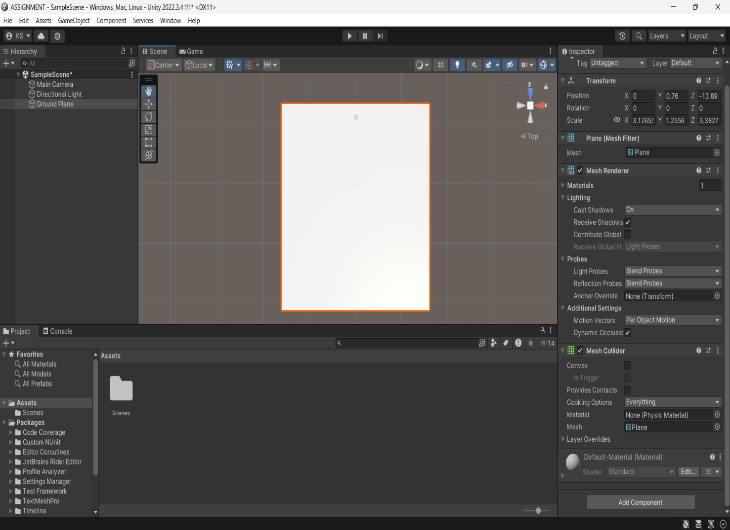

Successfully created a ground plane

**TASK 3: Add a Skybox [ 5 marks ]**

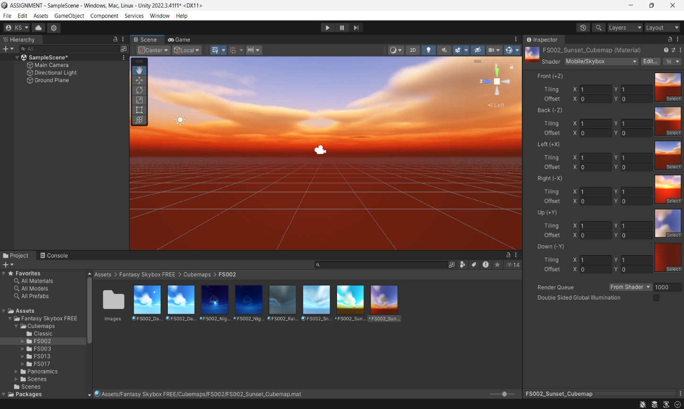

**Note : I have later changed the skybox according to the terrain look , which suits my scene**

**TASK 4 : Add Environment Objects [15 Marks]**

In Environment objects I have added : -

**Mountains** : I have added two types of mountains which gives realistic effect

**Ground** : other than that I have created a green ground layer for giving it a real safari look , I have added this in entire plane . I have also added grass !

**Animals** : animals like horses , deers , hen , tiger , Turtle ,Eagles and many more I have added

**Trees** : scenery look is incomplete without trees , so I have planted as many trees as I can in this scene !

**Stones** : I have placed different types of stones in different places

**Lets have a look of all of this :**

Image 1

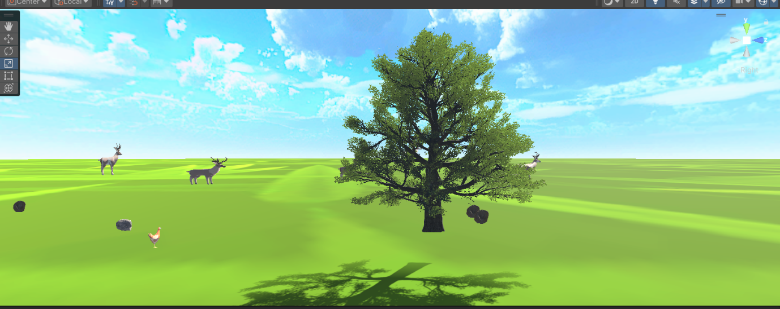

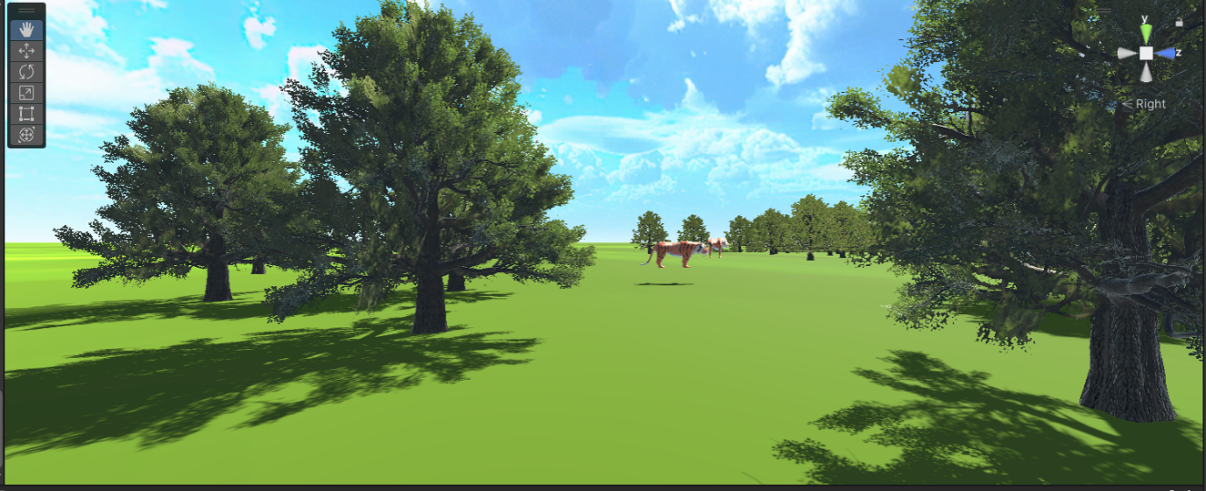

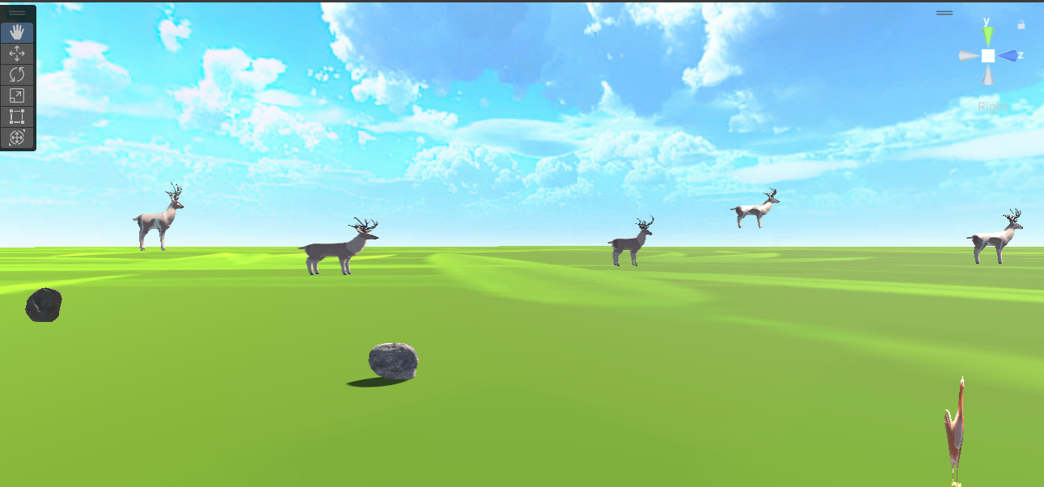

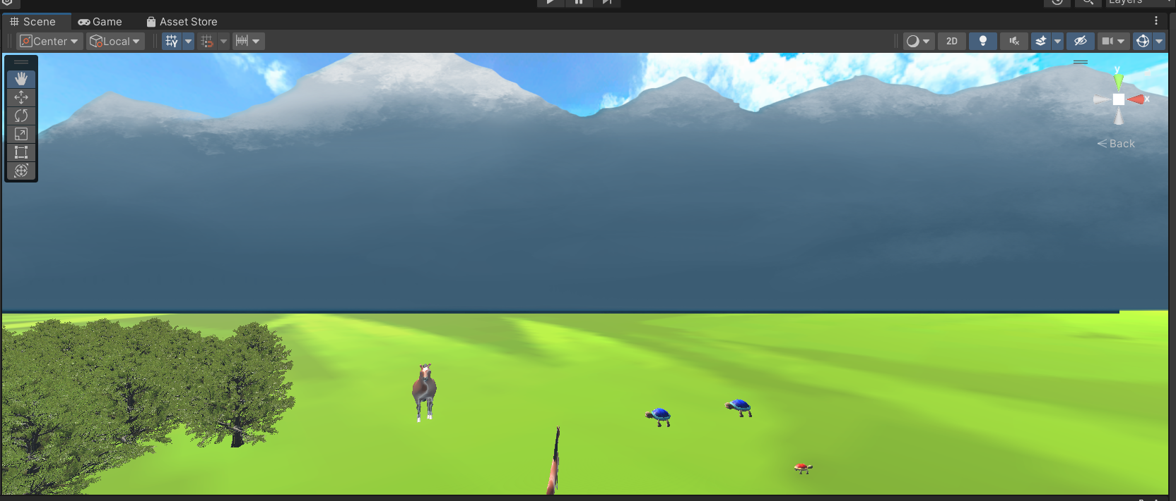

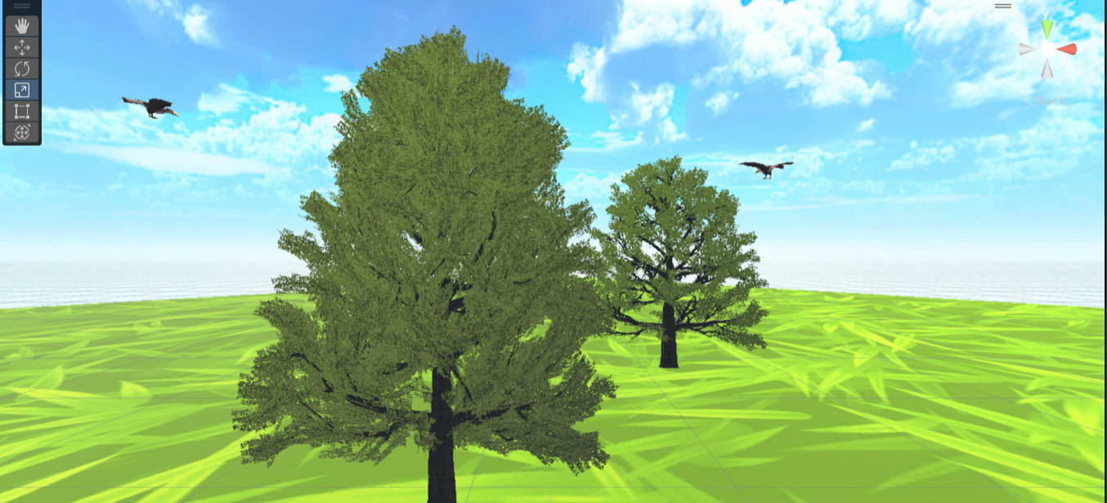

As u saw , I have added environment objects likes Trees , green ground , Mountains , Animals and Birds like Deer , Tiger , Horse , Hen , Turtle , Eagle and also added stones for better look !

I have tried to give realistic look by adding branches on trees and shadows and grasses

I even tried to make my sky look more cloudy .

Other than this we will see how I gave more realistic look by adding animations on objects in other tasks

**Task 6 : Configure Lightning and Shadows [5 Marks]**

Not only trees but every object have shadows

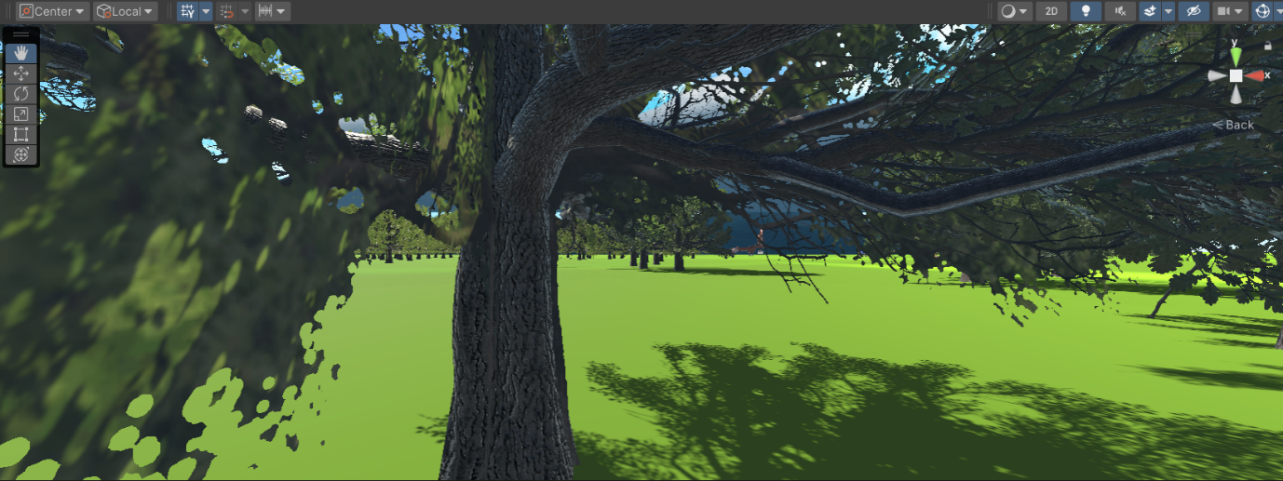

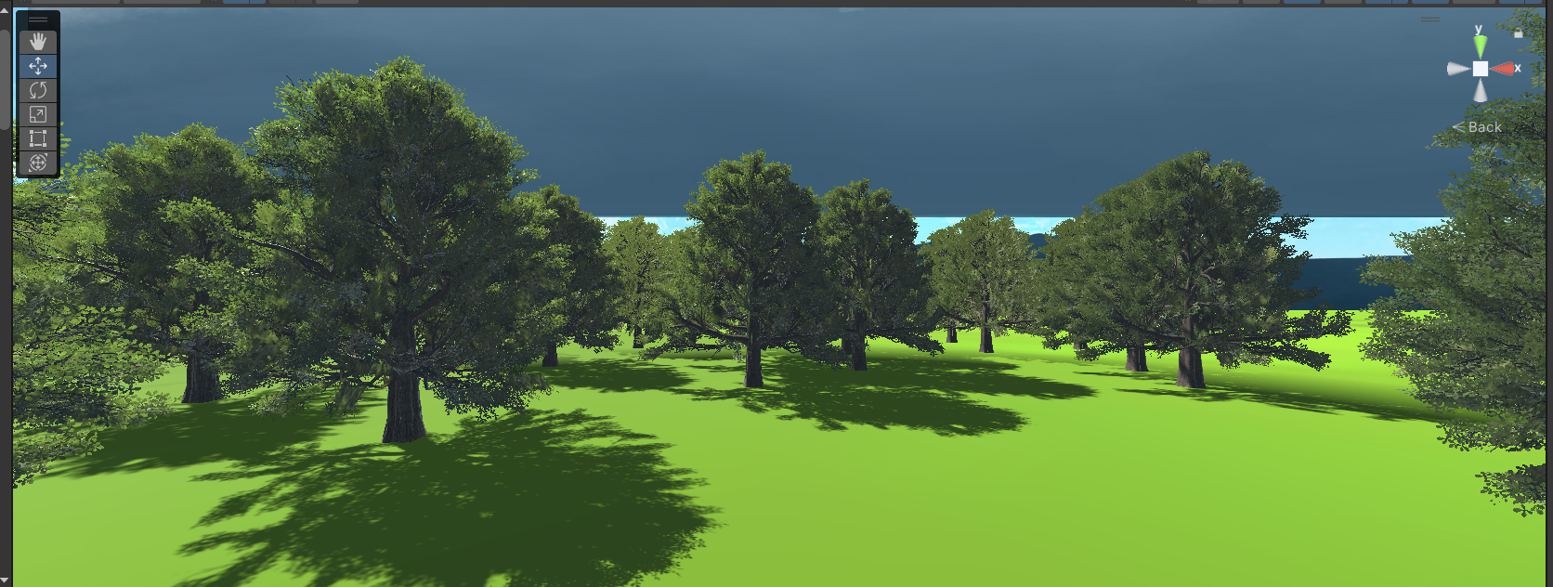



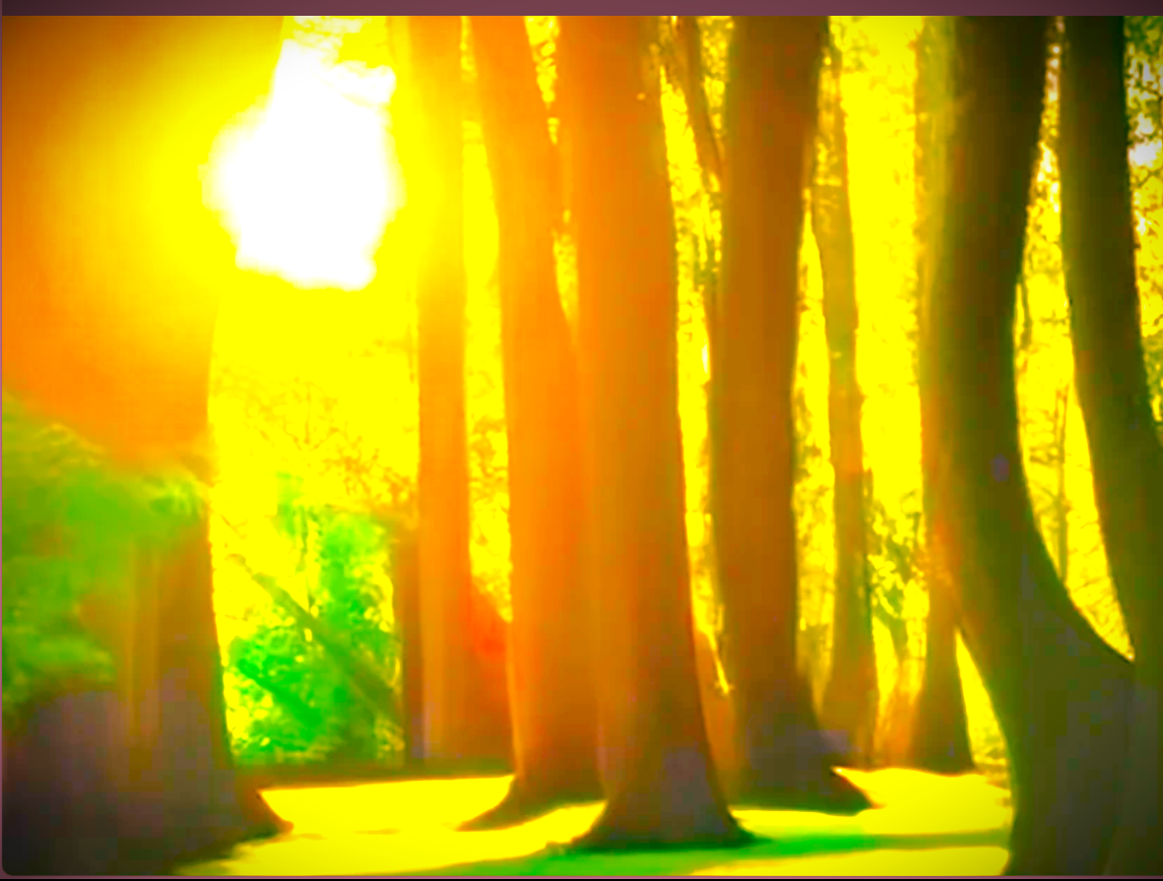

Tried this both and at the end , I have choosen this last one !

**Task 7 : Add audio [ 5 Marks]**

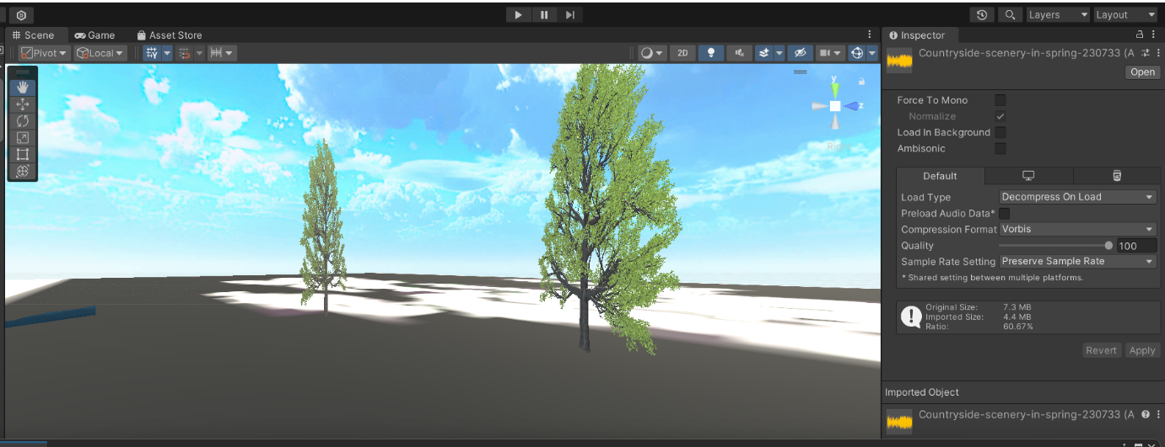

I have successfully import audio taken from google and imported it into assets and launched it !

Steps : How I did

1. **Download or Prepare Your Audio File**:
   * Make sure your music file is in **.mp3** or **.wav** format.
2. **Import the Audio Clip**:
   * Drag the music file into the **Assets** panel of the Unity editor, or right-click in the **Assets** window and select **Import New Asset**, then locate your audio file.

**Task 8 : Implement basic VR interaction [25 MARKS]**

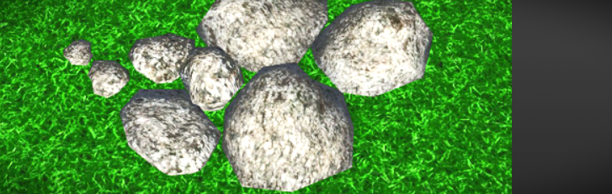

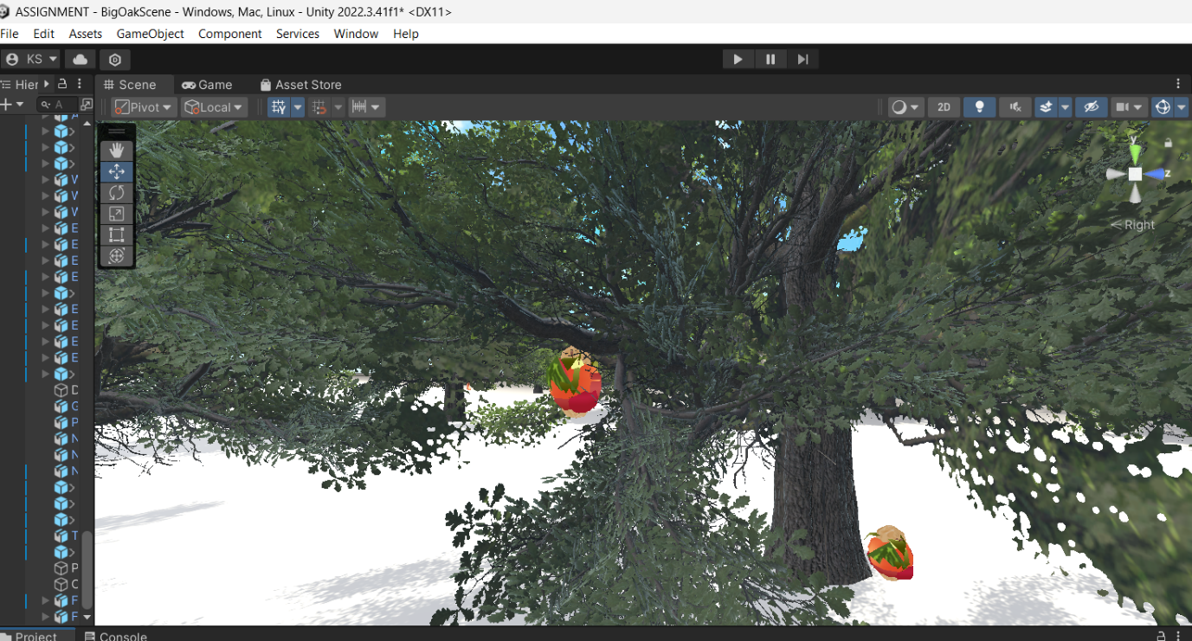

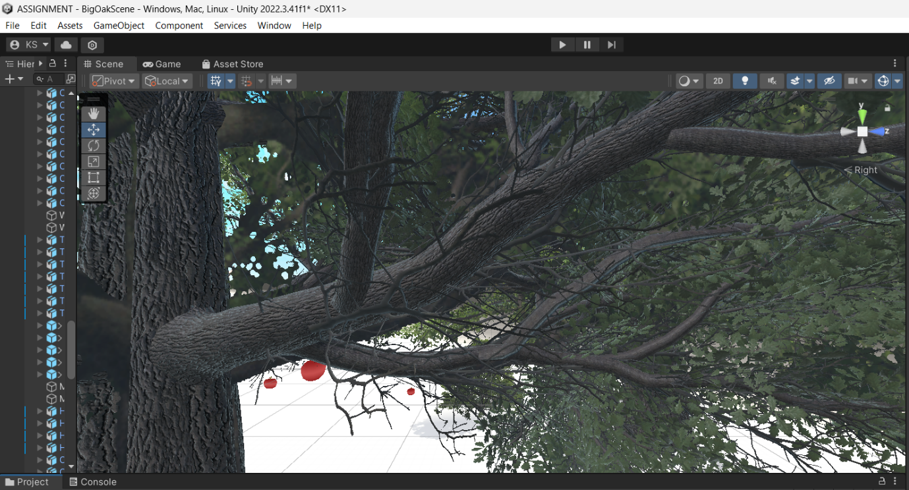

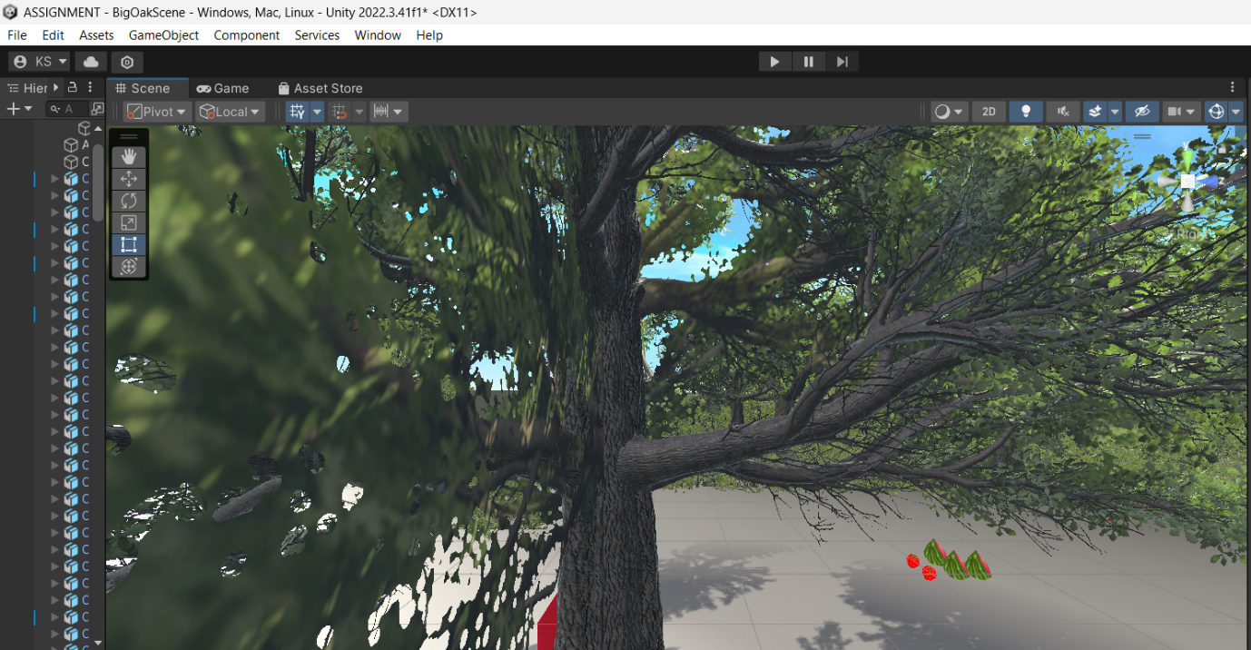

Every object in this scene is grabbable ! and moveable

In detail i wanna say

Trees are animated ! by windzone which give effects in realistic way

Animals are moving everywhere

Birds are flying ,

( I tried to give and hunt way in eagle but somehow its failed its just flying

Then all this scene I have already shown before , so to complete my task I added some new objects

Like leaves , and fruits ( apple , strawberry , watermelon , peanuts , avocado etc)

**Task 9 : Write VR Interaction Script [25 Marks]**

**This is basic grabbing script for VR interaction**

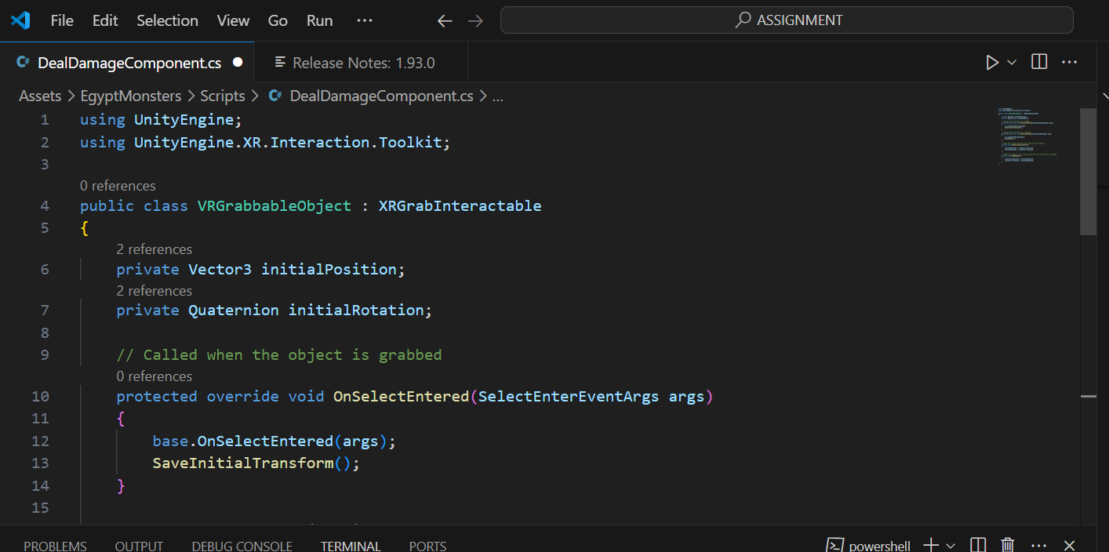

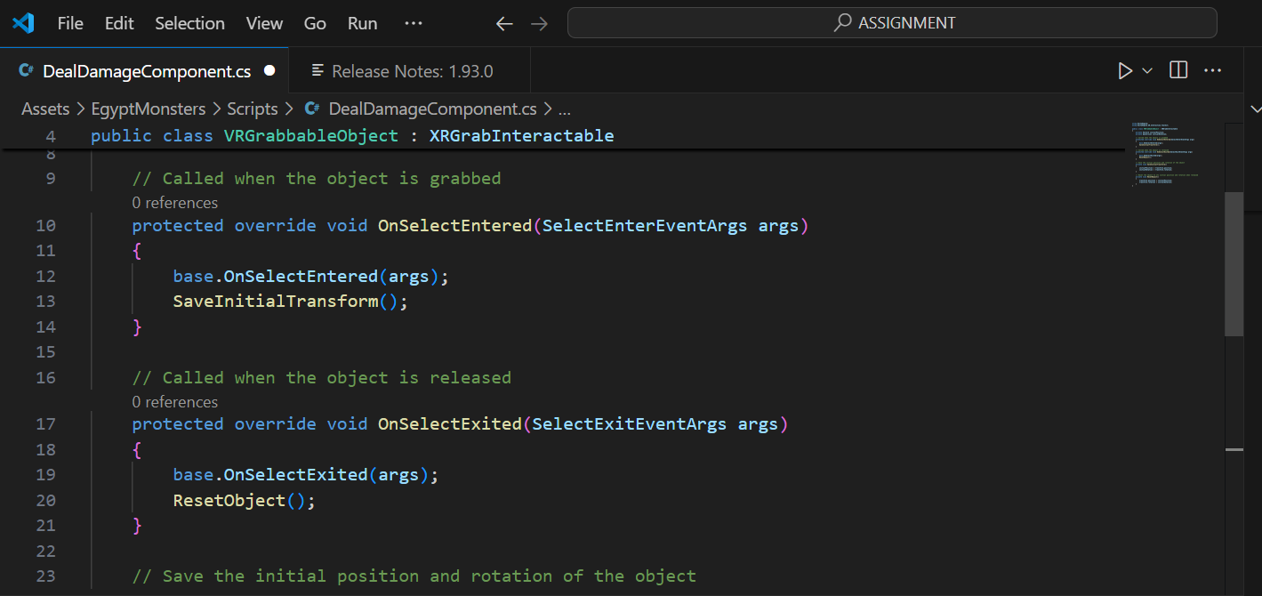

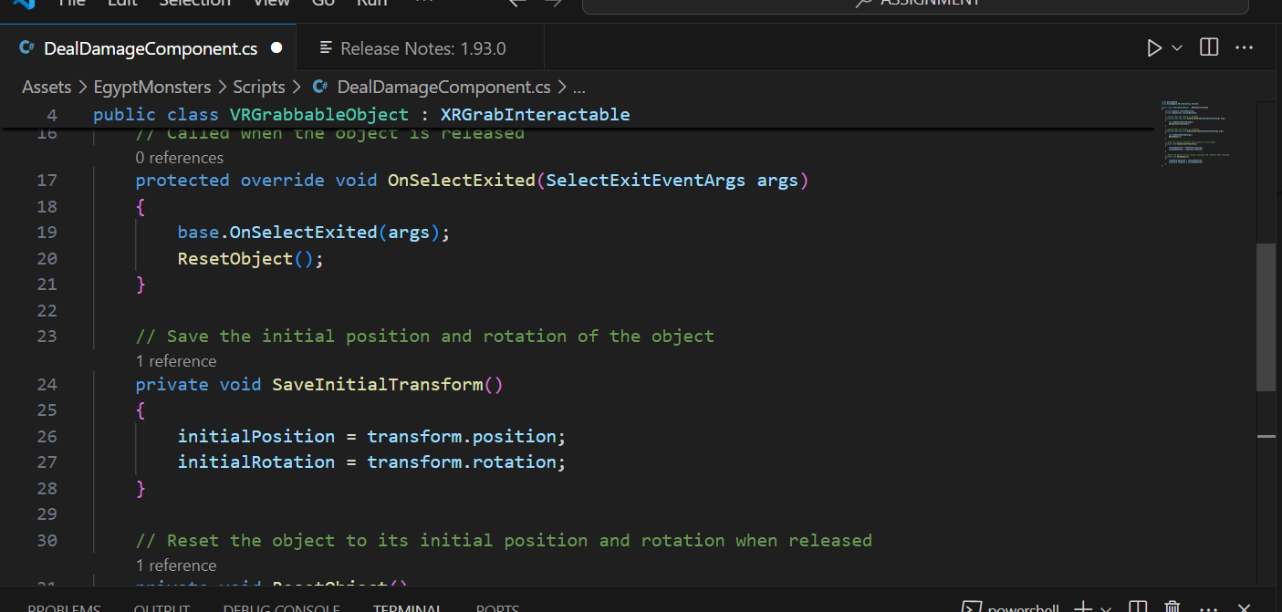

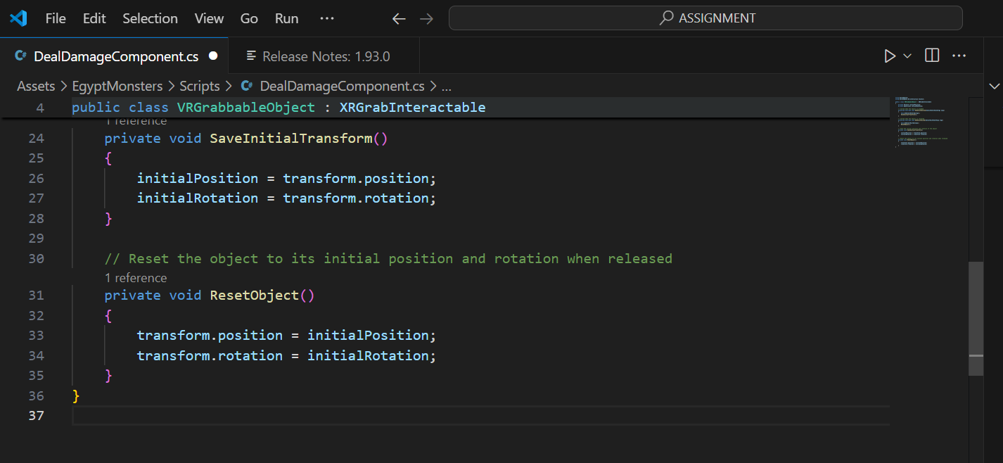

**Explanation of this script :**

1. **OnSelectEntered**: This method is called when the user grabs the object. The initial position and rotation of the object are saved.
2. **OnSelectExited:** This method is called when the user releases the object. The object is returned to its original position and rotation.

**Steps:**

* **Creating a script**
* **Adding script to grabbable objects**

**[** I have added script from youtube tutorials but somehow that was not working , So I took help of chatgpt by copying the error code to it ! ]

**Task 10 : Demo application [ 5 Marks]**

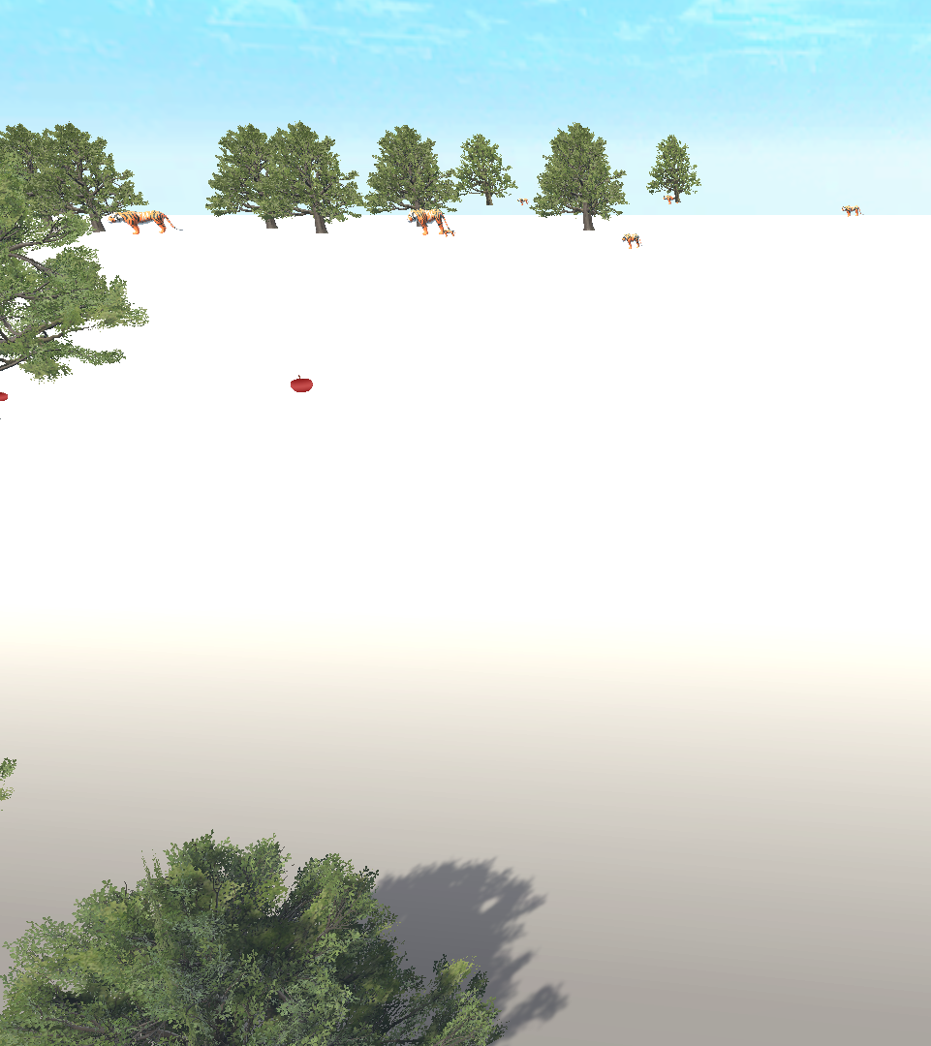

**Successful !**